John Michael Go
Career Entry Level Java Programming
Date: Jan. 17, 2013

DAY 5

Program Name: Assign3

Objective: Program computes for the total item amount and determines if payment is enough or requires adding more.

Algorithm:

- User inputs item number.
- User inputs item quantity.
- Program loops until option 5 is selected.
- Program outputs total item amount.
- User inputs payment.
- If payment is not enough, program will ask for additional amount.
- Program loops until total amount is reached.
- Program will display change.

Pseudocode:

import java.util.*;

public class Assign3 {

// static variable declaration
static final double CANDY_PRICE = 1;
static final double CHIPS_PRICE = 25;
static final double GUM_PRICE = 7;
static final double COOKIE_PRICE = 15;

static Scanner console = new Scanner (System.in);

public static void main(String[] args) {

// variable declaration
String addyn, Faddyn = null;
int prodNum, prodQty, prodItem;
double prodAmt = 0, TprodAmt=0, payAmt, TpayAmt, addAmt, payAmtadd=0, payAmtaddx=0, payAmtx, tChange;

// menu
System.out.println (" Candy Machine ");
System.out.println ("");
System.out.println (" Available Items: Prices:");
System.out.println ("");
System.out.println (" 1.) Candy Php 1.00");
System.out.println (" 2.) Chips Php 25.00");
System.out.println (" 3.) Bubble Gum Php 7.00");
System.out.println (" 4.) Cookies Php 15.00");
System.out.println (" 5.) Done ! ");
System.out.println ("");
System.out.println (" Product: Qty: Amount:");
System.out.println ("");
// for loop begin
for (prodNum = 0; prodNum != 5; prodNum = prodNum)
{
System.out.print (" Select Product: ");
prodNum = console.nextInt();
TprodAmt = TprodAmt + prodAmt;

switch (prodNum)
{ // product selection begin

case 1 :
System.out.print (" Candy ");
prodQty = console.nextInt();
prodAmt = prodQty * CANDY_PRICE;
System.out.print (String.format(" %.2f",prodAmt));
System.out.flush();
break;
case 2 :
System.out.print (" Chips ");
prodQty = console.nextInt();
prodAmt = prodQty * CHIPS_PRICE;
System.out.print (String.format(" %.2f",prodAmt));
System.out.flush();
break;
case 3 :
System.out.print (" Bubble Gum ");
prodQty = console.nextInt();
prodAmt = prodQty * GUM_PRICE;
System.out.print (String.format(" %.2f",prodAmt));
System.out.flush();
break;
case 4 :
System.out.print (" Cookies ");
prodQty = console.nextInt();
prodAmt = prodQty * COOKIE_PRICE;
System.out.print (String.format(" %.2f",prodAmt));
System.out.flush();
break;
case 5 :

} // product selection end

System.out.println ("\n");

} // for loop end
// accepts money
System.out.println (" ----------");
System.out.println (" Total Amount: Php " + String.format("%.2f",TprodAmt));
System.out.println ();
System.out.print (" Payment: Php ");
payAmt = console.nextDouble();
// paid amount is more or equal to the total item amount
if (payAmt >= TprodAmt)
{
System.out.println();
TpayAmt = payAmt - TprodAmt;
System.out.println (" Change : Php " + String.format("%.2f", TpayAmt));
System.out.println();
System.out.print(" Thank You, Come Again!");
}

// paid amount is lesser than the total item amount begin
else if (payAmt < TprodAmt)
{

payAmtaddx = payAmtaddx + payAmt ;
//check
//System.out.print(payAmtaddx);
// program loop until paid amount is greater or equal to the total item amount
for (payAmtaddx = payAmtaddx; payAmtaddx < TprodAmt; payAmtaddx = payAmtaddx)
{
// paid amount not enough and will ask if additional amount will be added
System.out.print("Total Amount Paid: Php " + String.format("%.2f", payAmtaddx));
System.out.println();
System.out.println("Your Payment is not enough...");
System.out.println();
System.out.print("Do you want to add another amount? (Y/N): ");
Faddyn = console.next();

switch (Faddyn)
{
case "Y":
case "y":
System.out.print (" Payment: Php ");
payAmt = console.nextDouble();
break;

case "N":
case "n":
System.out.println();
System.out.println(" Transaction cancelled");
System.out.print(" Thank You, Come Again!");
System.exit(0);
break;
}

// program adds amount paid until condition is not met

payAmtaddx = payAmt + payAmtaddx;

}
// computation for change

System.out.println();
System.out.println(" ------------");
tChange = payAmtaddx - TprodAmt;
System.out.print (" Change: Php "+ String.format("%.2f",tChange));
System.out.println();
System.out.print(" Thank You, Come Again!");

} // paid amount is lesser than the total item amount end

} // public static void end
} // public class end
Screenshot:

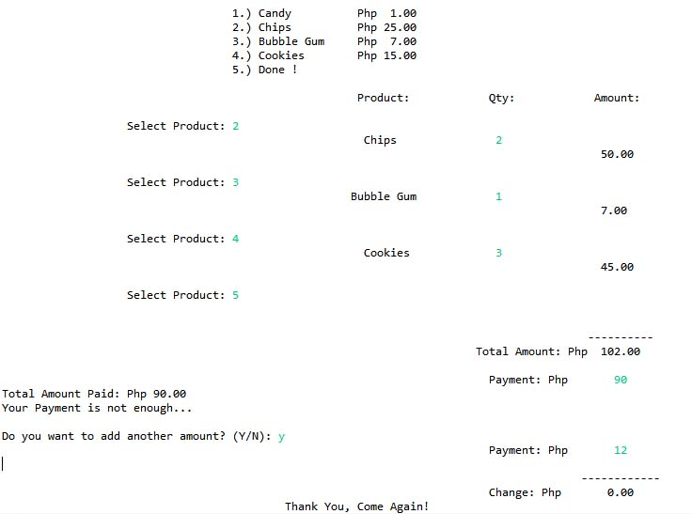

Flowchart:

